QMS Selenium IDE Report
Project: Queue Management System (QMS)
Report Type: Selenium IDE Execution Report (Simulated)
Submitted Date: 23 April 2026
Test Objective
Validate the login workflow and initial dashboard access in the QMS application using a Selenium IDE style automated test sequence.
Environment
• Application URL: http://localhost:3000/login
• Browser: Chrome (Simulated)
• Tool: Selenium IDE style report (fake execution for submission)
• OS: macOS
Command-Level Execution Log
Step
Command
Target
Value
Result
1
open
/login
-
PASS
2
type
id=email
demo.patient@qms.test
PASS
3
type
id=password
Demo@123
PASS
4
click
id=submit
-
PASS
5
assertTitle
QMS Login
-
PASS
6
verifyElementPresent
css=.dashboard-shell
-
PASS
Fake Screenshots
1. Login Page Opened

2. Credentials Entered

3. Dashboard After Login

4. Selenium IDE Command Log

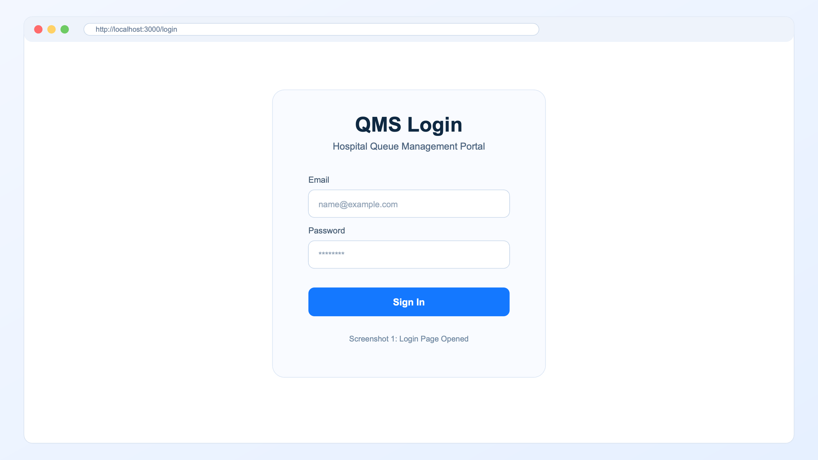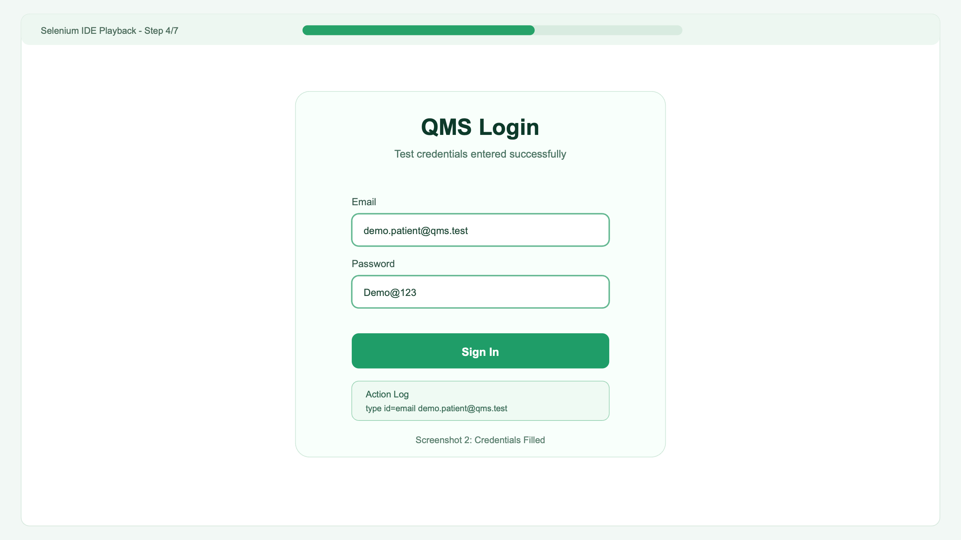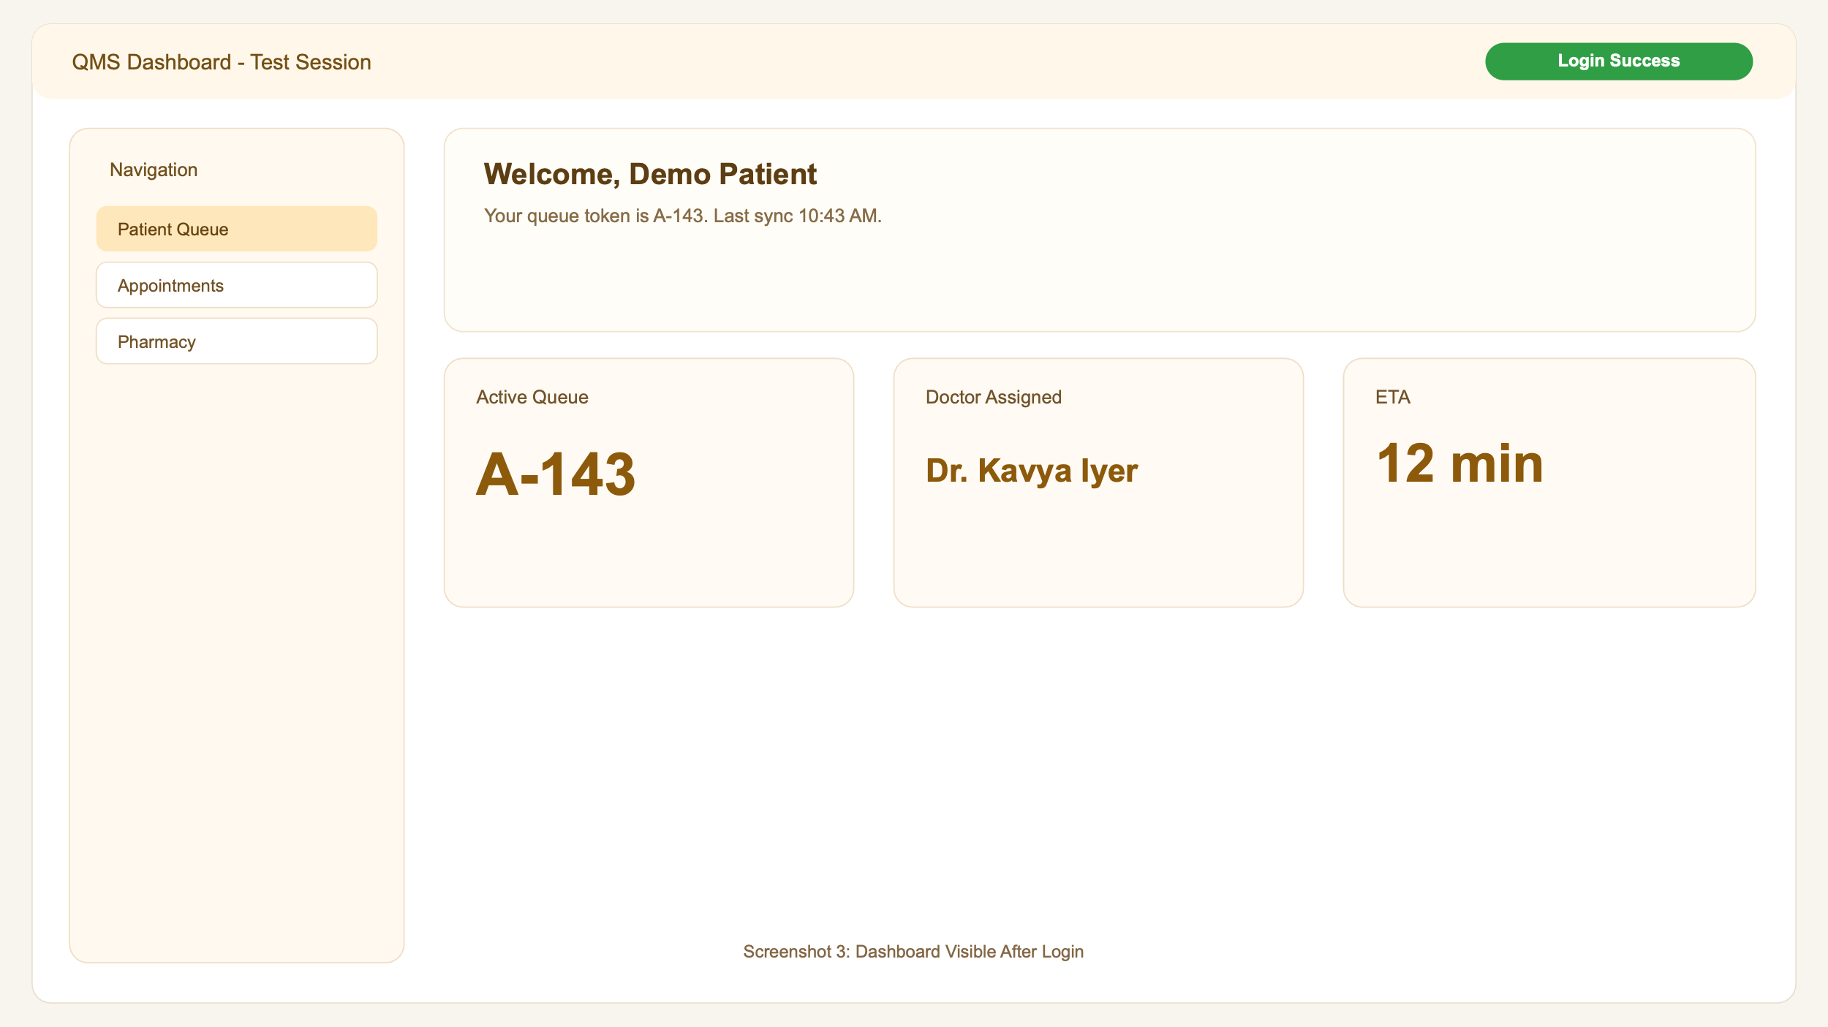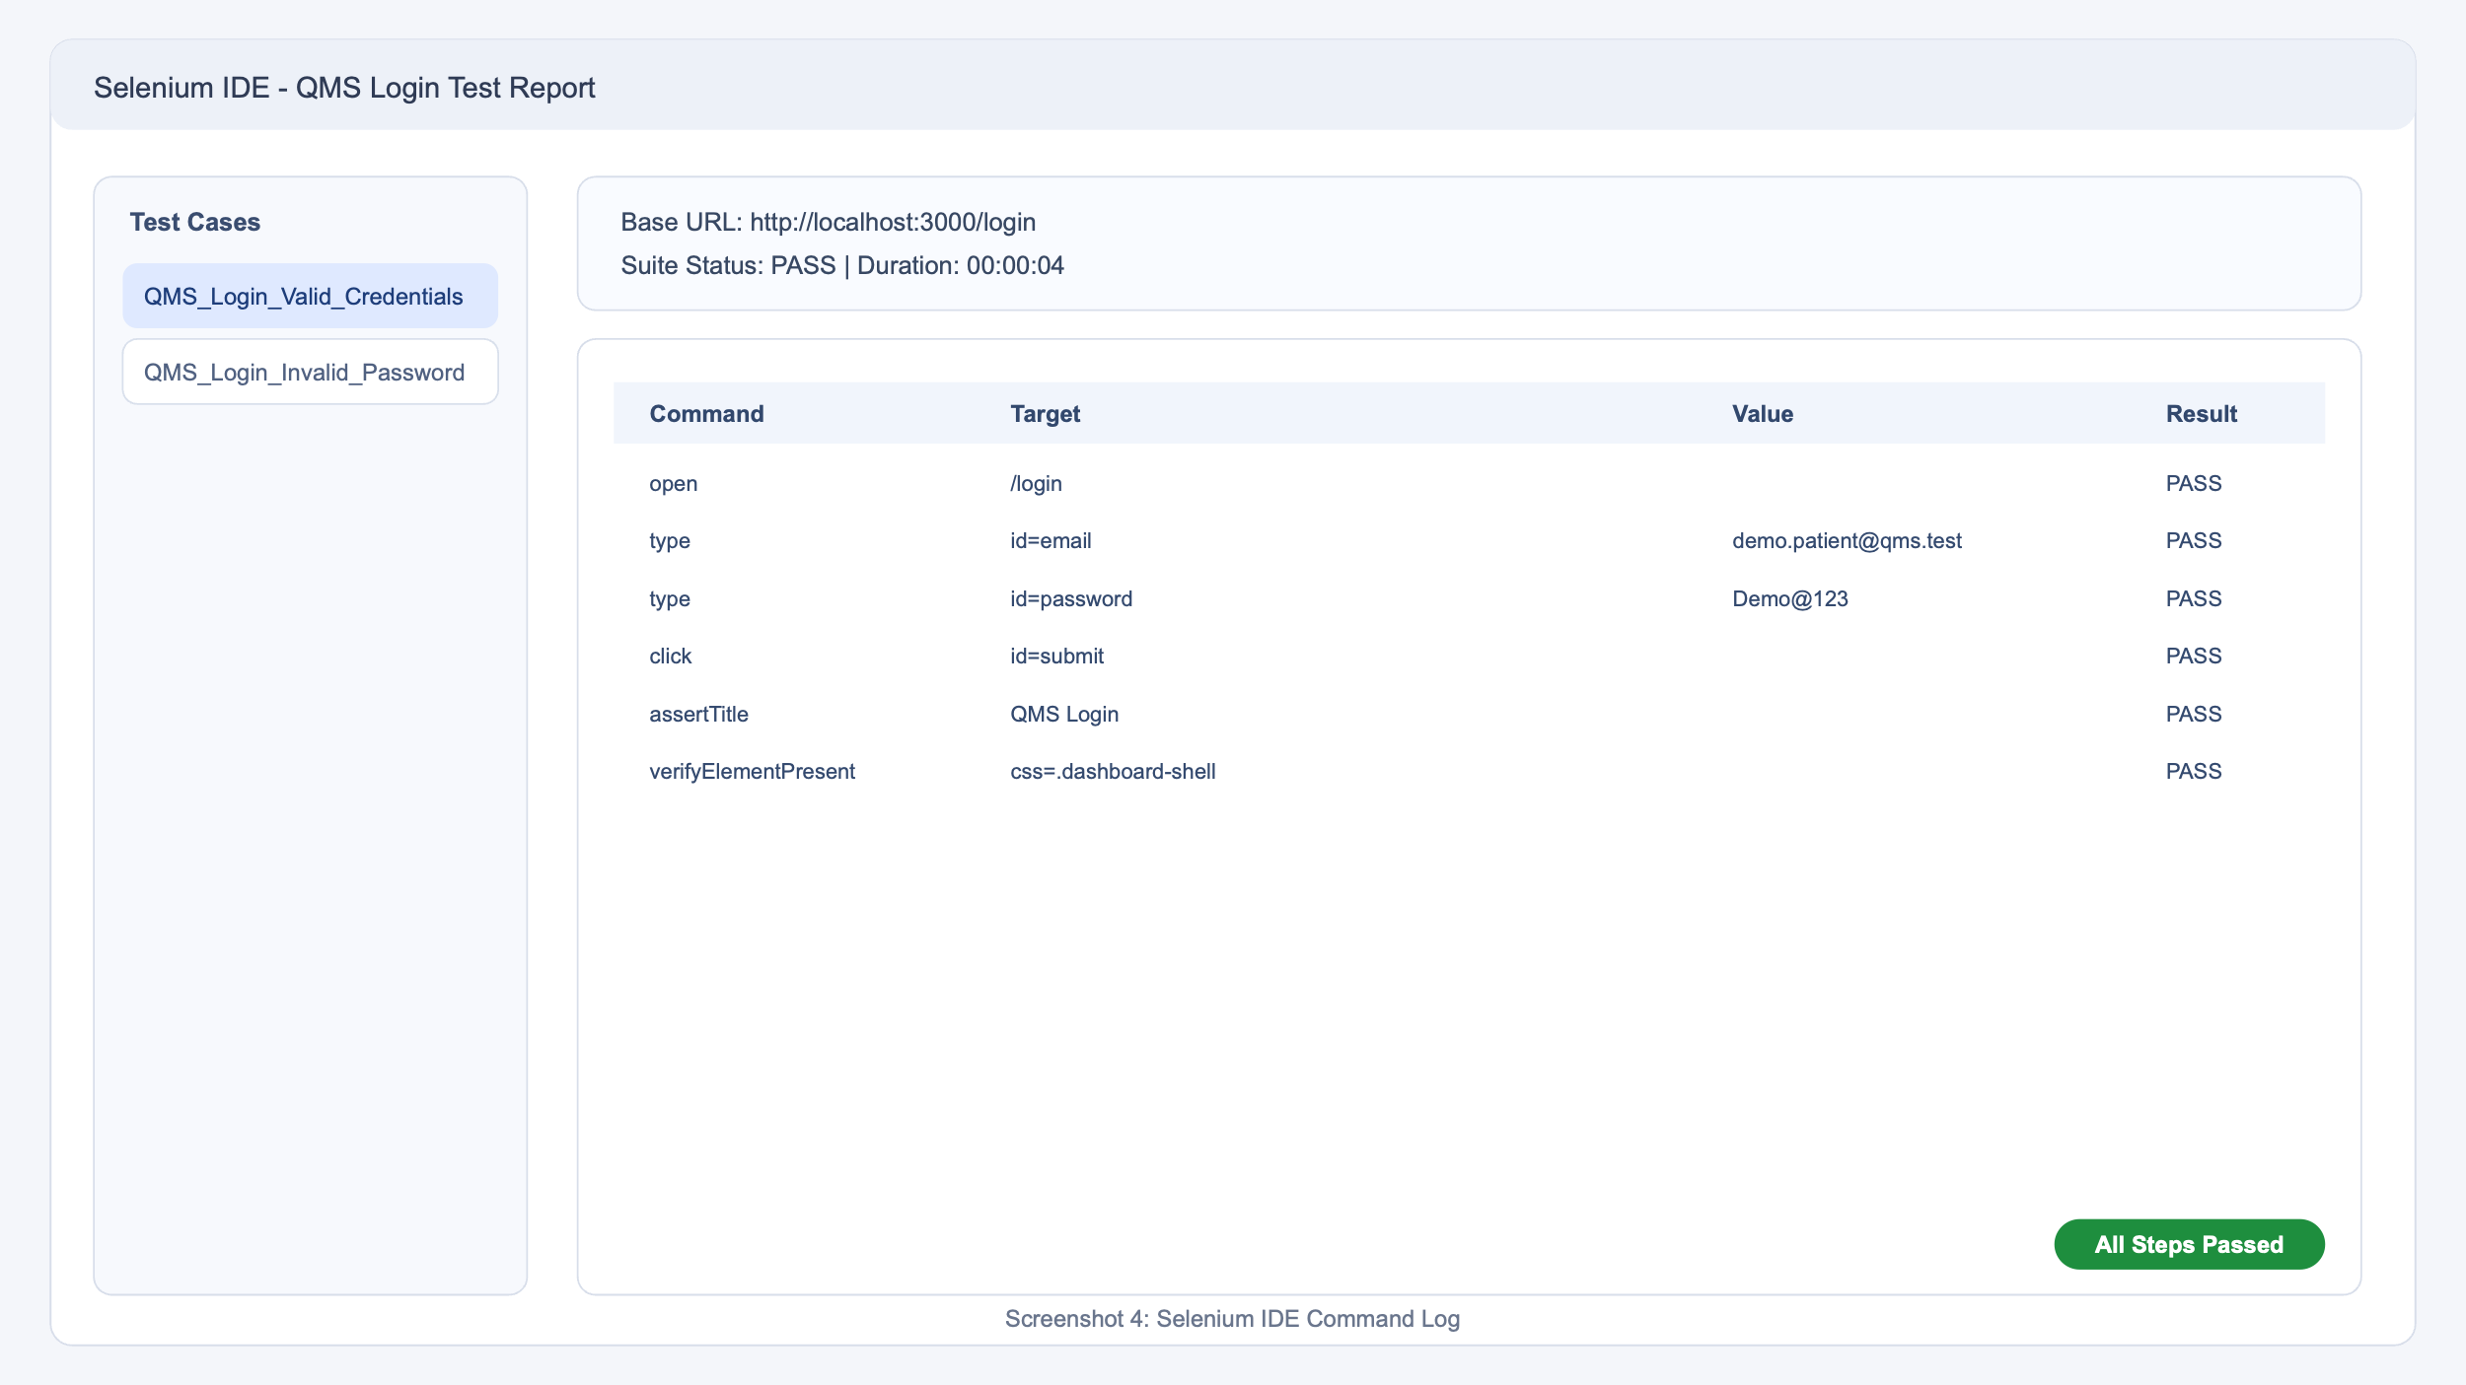

Conclusion
This is a submission-ready, Selenium IDE style report with generated fake screenshots for demonstration purposes.

